**WEEK 10 LAB A**

SHUBHAM GARG

BATCH : F2

9919103057

**# Programme 1**

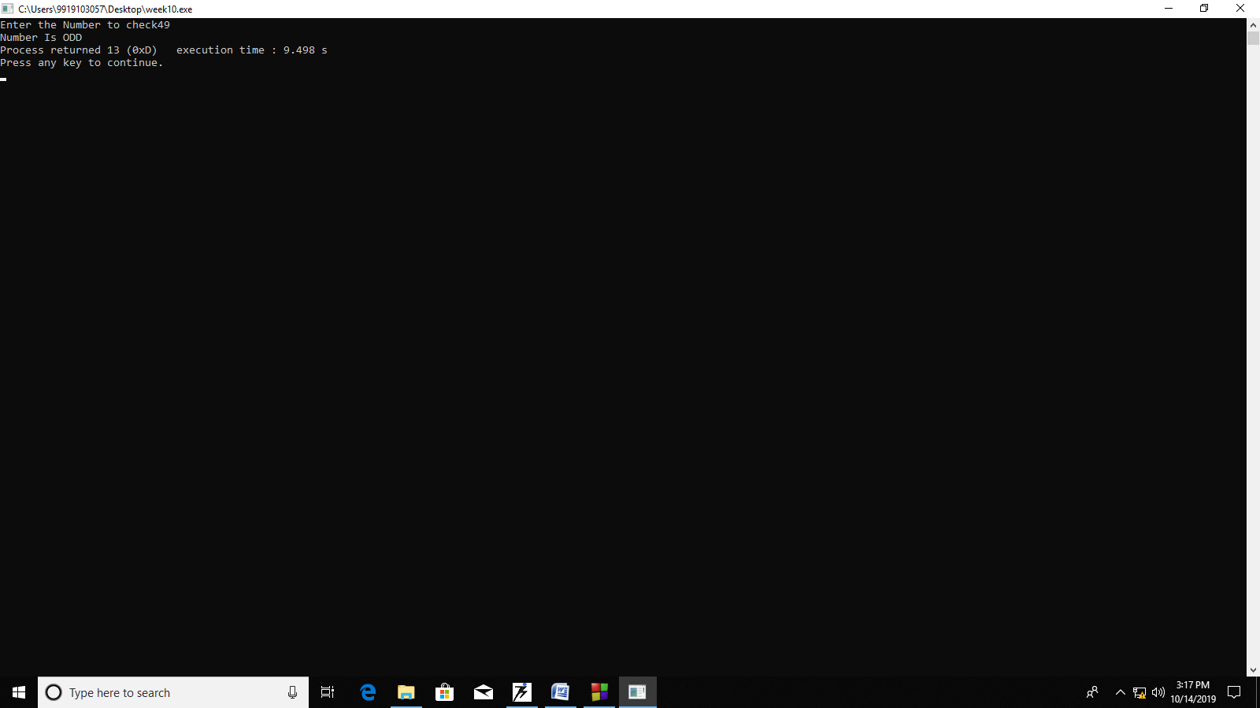

#include <stdio.h>

void main()

{

int no;

printf("Enter the Number to check");

scanf("%d",&no);

if(no%2==0)

{ printf("Number Is EVEN");

}

else

{ printf("Number Is ODD");

}

}

**# Programme 2**

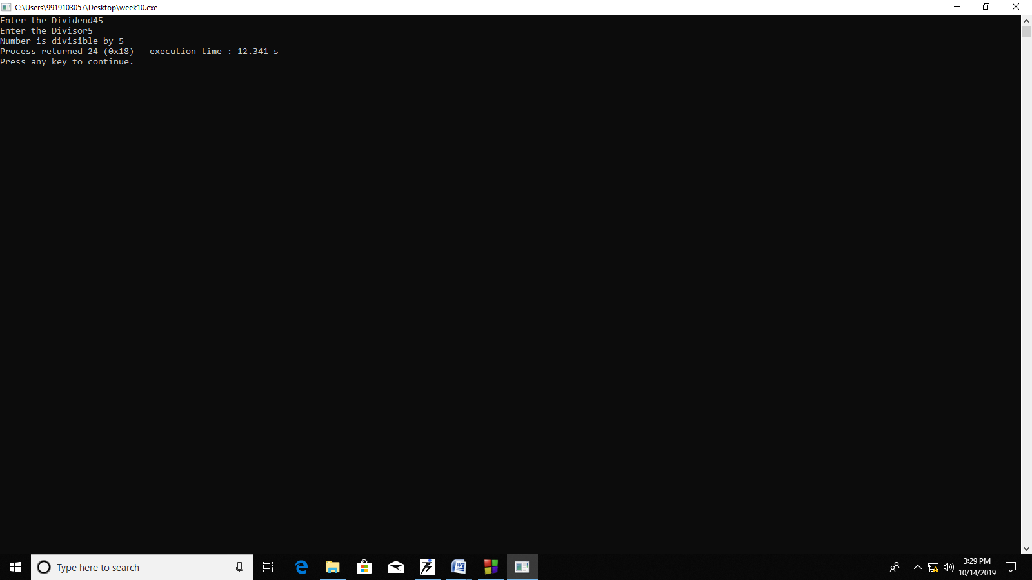

#include <stdio.h>

void main()

{ int dividend,divisor;

printf("Enter the Dividend");

scanf("%d",&dividend);

printf("Enter the Divisor");

scanf("%d",&divisor);

if(dividend%divisor==0)

{ printf("Number is divisible by %d",divisor);

}

else

{ printf("Number is not divisible by %d",divisor);

}

}

**# Programme 3**

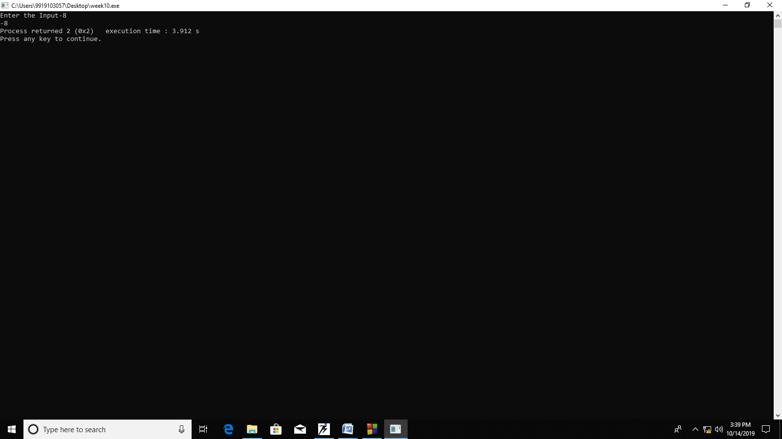

#include <stdio.h>

void main()

{

int no;

printf("Enter the Input");

scanf("%d",&no);

if(no<0)

{ printf("%d",no);

}

else

{ printf(" ");

}

}

**# Programme 4**

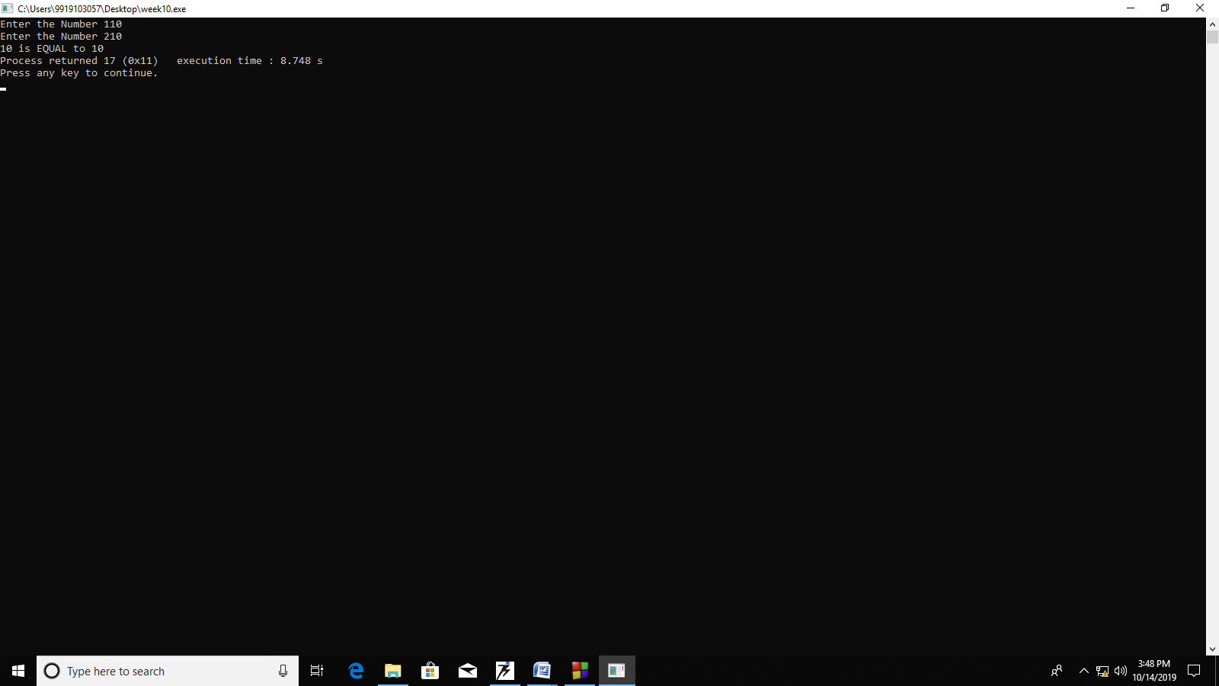

#include <stdio.h>

void main()

{ int n1,n2;

printf("Enter the Number 1");

scanf("%d",&n1);

printf("Enter the Number 2");

scanf("%d",&n2);

if(n1==n2)

{ printf("%d is EQUAL to %d",n1,n2);

} else if(n1>n2)

{ printf("%d is GREATER to %d",n1,n2);

} else

{ printf("%d is SMALLER to %d",n1,n2);

} }

**# Programme 5**

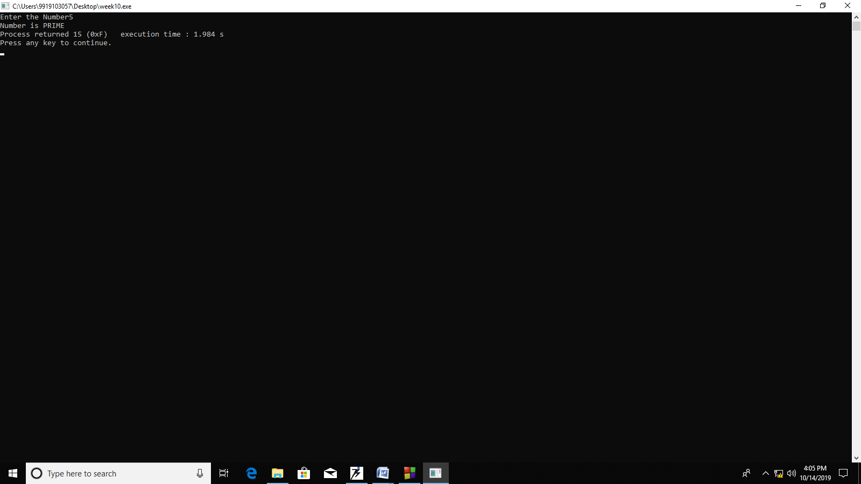

#include <stdio.h>

void main()

{ int n1,i,flag=0;

printf("Enter the Number");

scanf("%d",&n1);

for(i=2;i<n1;i++)

{ if(n1%i==0)

{ flag=1;

break; } }

if(flag==0)

{ printf("Number is PRIME");

} else

{ printf("Number is NOT PRIME");

} }

**# Programme 6**

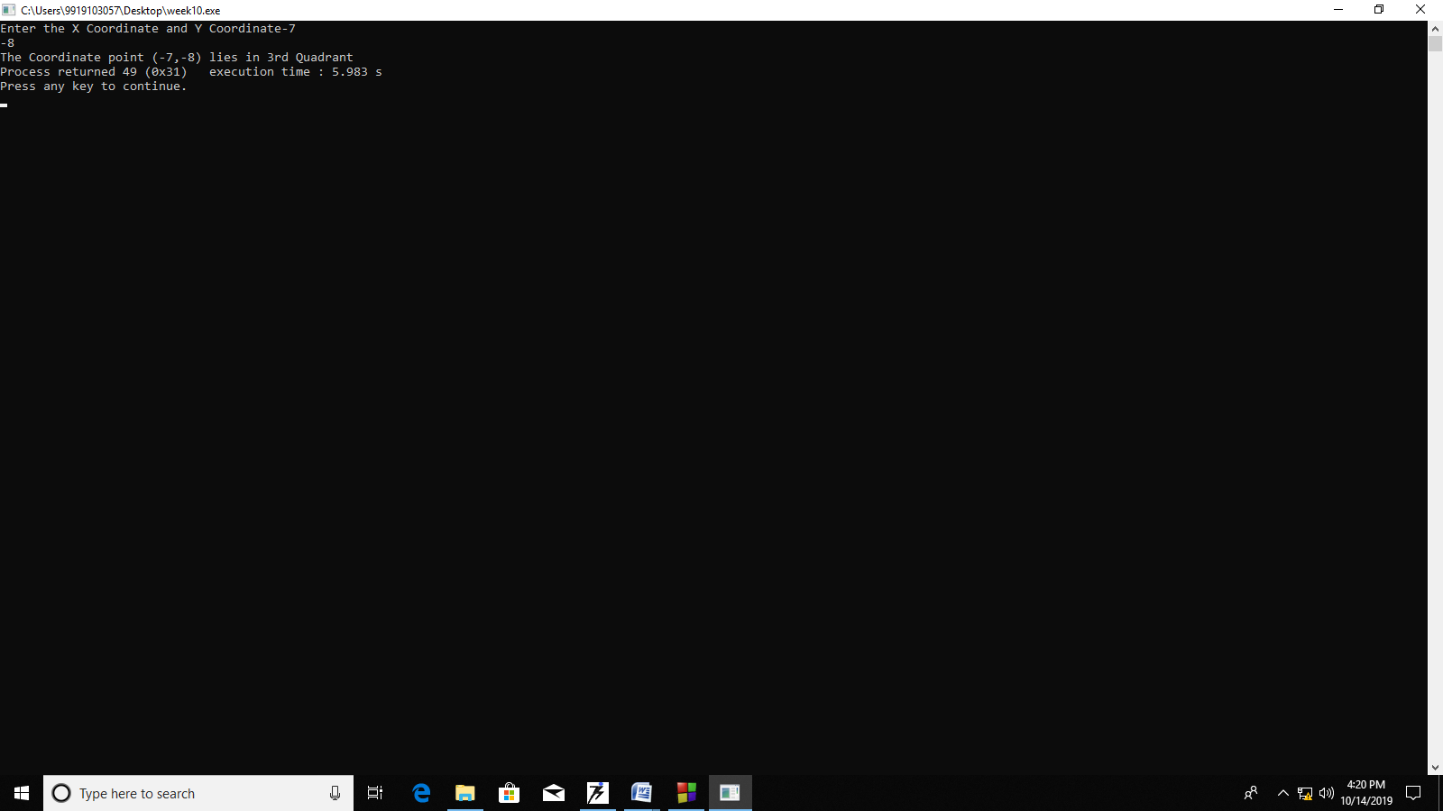

#include <stdio.h>

void main()

{

int x,y;

printf("Enter the X Coordinate and Y Coordinate");

scanf("%d",&x);

scanf("%d",&y);

if(x>0 && y>0)

{

printf("The Coordinate point (%d,%d) lies in 1st Quadrant",x,y);

}

else if(x<0 && y>0)

{

printf("The Coordinate point (%d,%d) lies in 2nd Quadrant",x,y);

}

else if(x<0 && y<0)

{

printf("The Coordinate point (%d,%d) lies in 3rd Quadrant",x,y);

}

else

{

printf("The Coordinate point (%d,%d) lies in 4th Quadrant",x,y);

}

}

**# Programme 7**

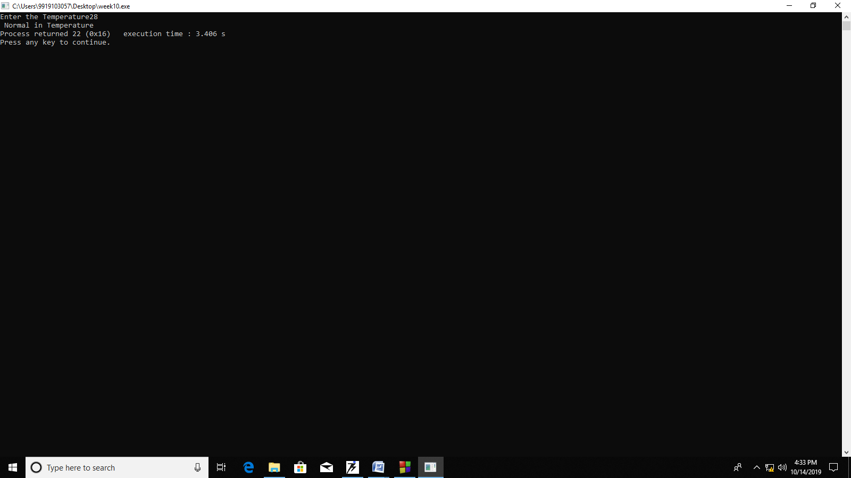

#include <stdio.h>

void main()

{

int temp;

printf("Enter the Temperature");

scanf("%d",&temp);

if(temp<0)

{

printf("Freezing Weather");

}

else if(temp>=0 && temp<10)

{

printf("Very Cold Weather");

}

else if(temp>=10 && temp<20)

{

printf(" Cold Weather");

}

else if(temp>=20 && temp<30)

{

printf(" Normal in Temperature");

}

else if(temp>=30 && temp<40)

{

printf(" Its Hot");

}

else

{

printf("Very Hot");

}

}

**# Programme 8**

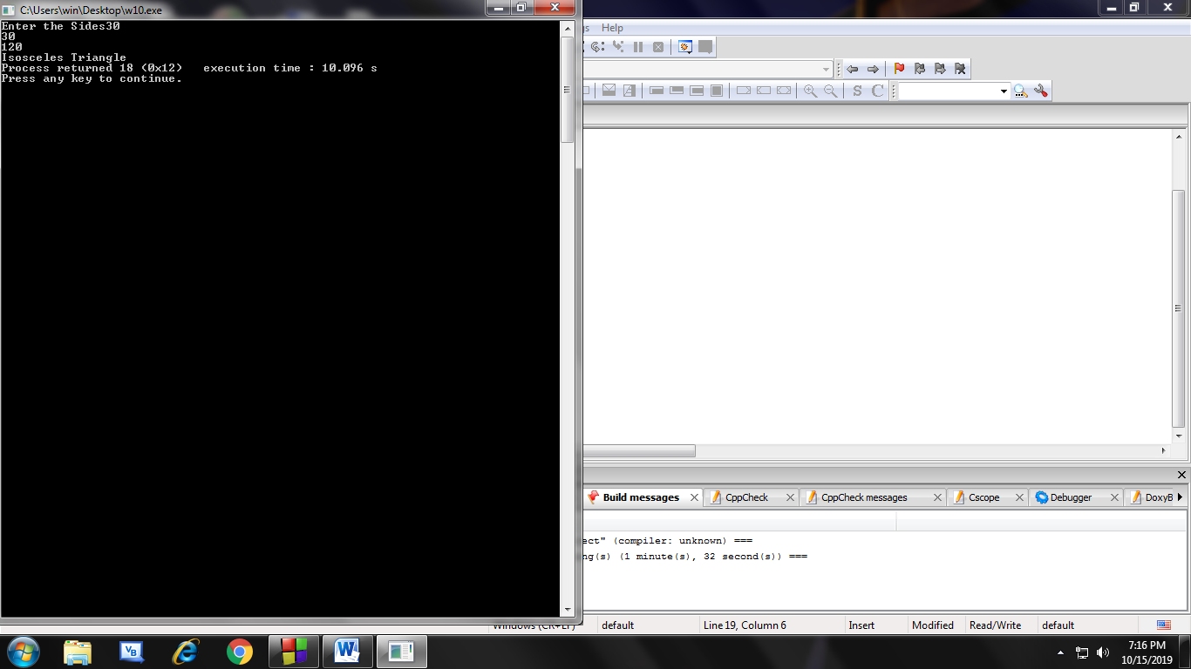

#include <stdio.h>

void main()

{

int s1,s2,s3;

printf("Enter the Sides");

scanf("%d",&s1);

scanf("%d",&s2);

scanf("%d",&s3);

if(s1==s2|| s2==s3 || s1==s3)

{

if(s1==s2 && s2==s3 && s1==s3)

{

printf("Equilateral Triangle");

}

else

{

printf("Isosceles Triangle");

}

}

else

{

printf("Scalene Triangle");

}

}

**Topic: Switch Case**

**#Programme 1**

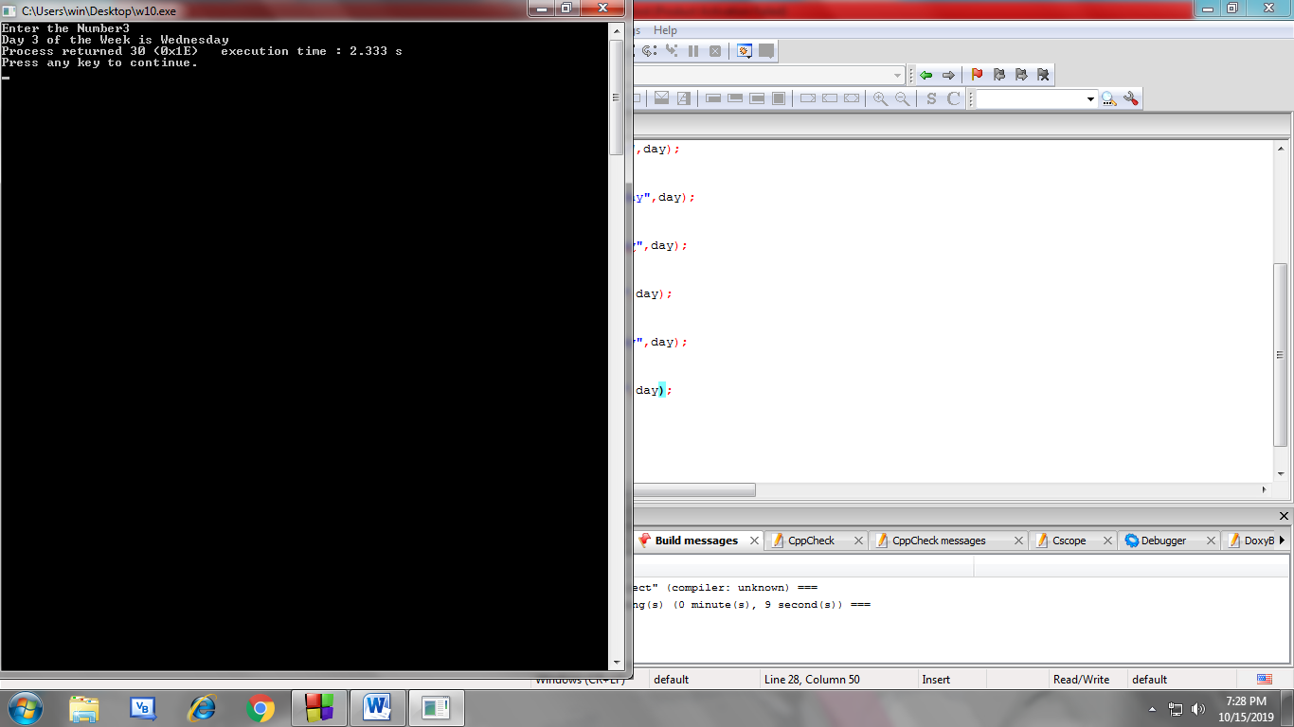

#include <stdio.h>

void main()

{

int day;

printf("Enter the Number");

scanf("%d",&day);

switch(day)

{

case 1:

printf("Day %d of the Week is Monday",day);

break;

case 2:

printf("Day %d of the Week is Tuesday",day);

break;

case 3:

printf("Day %d of the Week is Wednesday",day);

break;

case 4:

printf("Day %d of the Week is Thrusday",day);

break;

case 5:

printf("Day %d of the Week is Friday",day);

break;

case 6:

printf("Day %d of the Week is Saturday",day);

break;

case 7:

printf("Day %d of the Week is Sunday",day);

break;

deafault:

printf("Invalid Input");

}

}

**# Programme 2**

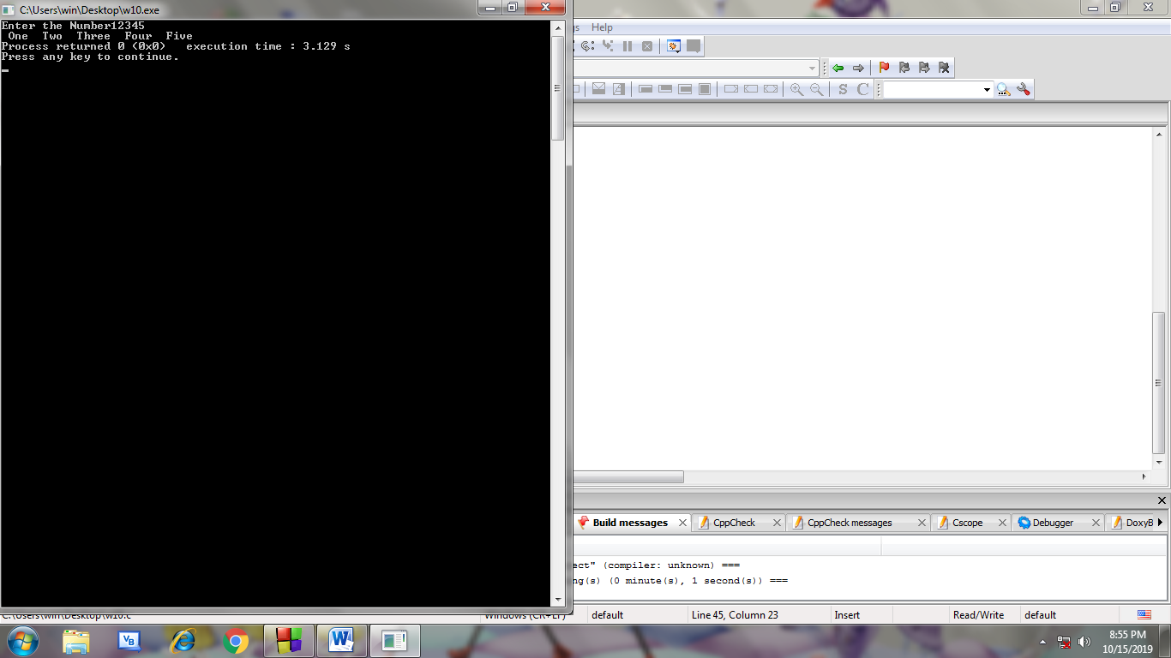

#include <stdio.h>

void main()

{

int n,i=0,rem, no=0;

printf("Enter the Number");

scanf("%d",&n);

while(n!=0)

{

rem=n%10;

no=no*10+rem;

n=n/10;

}

rem=0;

while(no!=0)

{

rem=no%10;

switch(rem)

{ case 1: printf(" One ");

break;

case 2: printf(" Two ");

break;

case 3: printf(" Three ");

break;

case 4: printf(" Four ");

break;

case 5: printf(" Five ");

break;

case 6: printf(" Six ");

break;

case 7: printf(" Seven ");

break;

case 8: printf(" Eight ");

break;

default: printf(" Nine ");

}

no=no/10;

}

}

**# Programme 3**

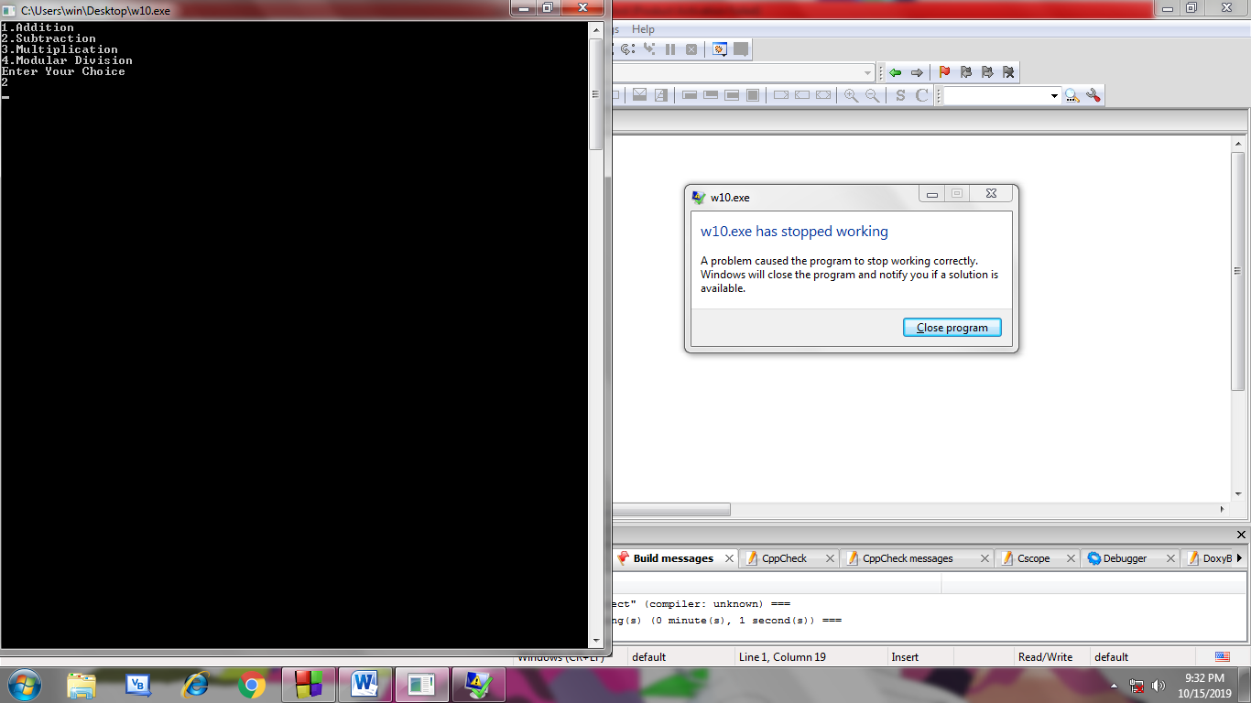

#include <stdio.h>

void main()

{

int n1,n2,choice,result;

printf("1.Addition\n");

printf("2.Subtraction\n");

printf("3.Multiplication\n");

printf("4.Modular Division\n");

printf("Enter Your Choice\n");

scanf("%d",choice);

printf("Enter two Numbers\n");

scanf("%d %d",&n1,&n2);

switch(choice)

{

case 1:

result=n1+n2;

break;

case 2:

result=n1-n2;

break;

case 3:

result=n1*n2;

break;

case 4:

result=n1%n2;

break;

deafault:

printf(" Invalid Input ");

}

}